* **Command Execution**

* **Background Process Execution using “&”**

* **Command History using “!!”**

* **Input/Output Redirection using “<” and “>”**

**“>”**

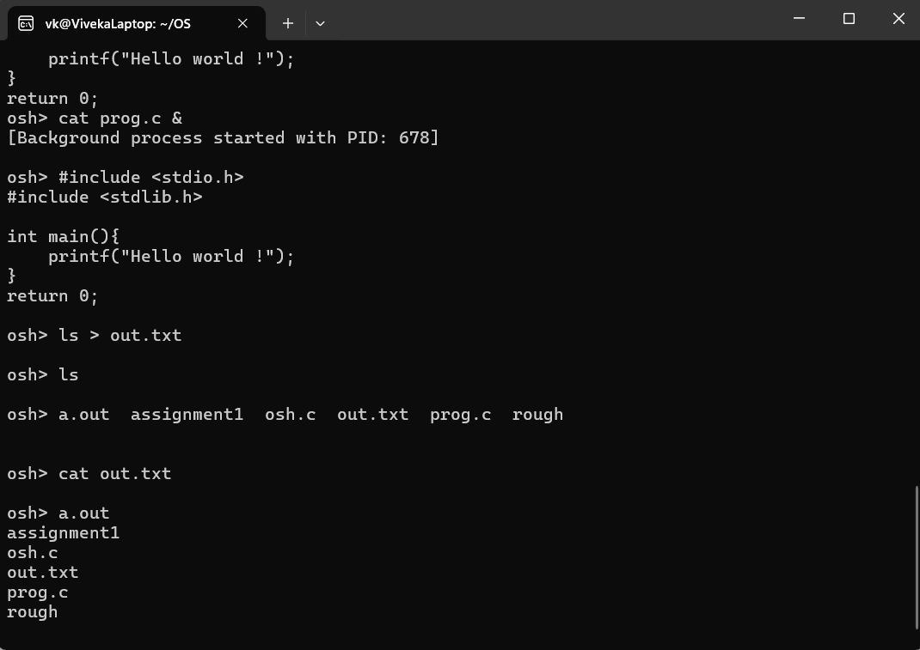

**“<”**

* **Pipe support by “I”**

